**Unit 8: The Effect of Varying a Parameter in Autonomous Differential Equations**

Goals/Rationale

This unit offers a capstone experience where students bring together much of their previous qualitative, graphical and modeling work with autonomous differential equations. Students must therefore make robust connections across representations, interpret analyses in terms of a real world situation, and develop a powerful new idea in the process. In particular, students will either reinvent or be introduced to the concept of bifurcation and bifurcation diagrams. In previous units students reasoned about the structure of solution spaces (i.e., the number and nature of equilibrium solutions) and in this unit they will investigate the effect that varying a parameter has on the solution space. Students also will have the opportunity to act as “consultants” to the fish.net company and prepare and present a report synthesizing their analysis.

We should include a link to the GeoGebra applet. This applet allows you to choose between two models and visualizes the critical points as intersections between the parabola 2P(1-P/25) and horizontal line at height k or 2P(1-P/25) and the line with slope k. In this diagram, the pink critical point is stable, and the black is stable. To connect with formal language and notation, the 2P(1-P/25) - k bifurcation diagram is the “saddle node” or “fold” bifurcation, while the 2P(1-P/25) - kP bifurcation diagram is the “transcritical” bifurcation.

**Pages 8.1- 8.3 – Fish Harvesting**

Implementation

Ideally the entire unit, which consists of three problems, will take two 75-minute class periods or three 50-minute class periods. One full class period should be devoted to group presentations of their report to the owners of fish.net. Problems 1 and 2 should be done in class and Problem three should be started in class (10-15 minutes is sufficient) and students should be instructed to meet with their groupmates to complete their analysis and develop their report outside of class.

*Problem 1* – In this problem students develop an analysis of the given differential equation and this analysis will serve in subsequent problems as a baseline case. It is important that students have a good grasp of the connections between the graph of dP/dt vs P, phase line, and slope field and/or graphs of representative solution graphs. Some discussion questions to promote these connections:

* The solution graphs show that there is an inflection point for some solutions. How do you see the inflection point on the graph of dP/dt vs P? What does this inflection point mean in terms of the fish population?
* How would you classify the equilibrium solutions and what do these mean in terms of the fish population?
* Where would you draw a phase line on the slope field (or representative solution graphs)? Where would you draw it on the graph of dP/dt vs P?
* Which of the three representations (phase line, graph of dP/dt vs P, slope field) is your favorite and why?

*Problem 2 -*  This problem gives students a chance to create a modified differential equation based on a change to the fishery. While a constant harvesting rate may not make sense for some areas of the country, it is a reasonable start for areas of the country that do not experience wide fluctuations in temperature. Students are given two possible modifications to consider with the option of creating other modifications. The best case scenario is that at least one group comes up with a different modification, namely dP/dt = 2P(1 – P/25) – k. They may think about this in terms of the rule of thumb, rate in minus rate out. This modification will be used in the next problem, so encourage students to be creative and come up their own modification. The goal is to settle on and develop some intellectual ownership in dP/dt = 2P(1 – P/25) – k.

* One way to dissuade students from the -kP model (which harvests a percentage of the population) is to bring up the practical limitations for knowing the number of fish in the lake.
* For model (b), students may not agree with this model because P is a number of fish and k is a harvesting rate, thus it doesn’t make sense to subtract a rate from a population.

Students will likely not be very precise on the units for k. Many are likely to think of k as the number of fish, so it would be useful at some point to the units for k in the modification above are fish/year.

*Problem 3* – Have students begin work in groups to analyze the effect of different harvesting rates, k, on the future fish populations. They will have to finish their analysis and develop their one page report outside of class.

* Encourage students to use GeoGebra or excel or any other software they like. This can be especially useful for considering the effect of changing k on the graph of dP/dt vs P.
* It is critical to stress (over and over) that their job is NOT to answer the question, “what is the best k value”, their job is to prepare a report to the new owners illustrating what will happen with different k values. It is the owners job to decide what to do once they have the information – their job is to provide them information.
* Also, we have found it productive for each group to prepare a single report for the group and to present their report the next class period. Stress that their report must be confined to **one page**. The (secret) reason for this is that we want to encourage students to consolidate their analysis in a way that makes sense to them. Plus, no one wants to see page after page of graphs and interpretation. The owners of fish.net are busy people! On occasion, students create what an expert would recognize as more or less a bifurcation diagram.

The next class period have each group present their report. Depending on the number of groups, it may not be necessary to have all groups present – after looking at what each has to offer, ask those groups that have different ways of illustrating their results to present.

* Invite students to pretend they are the owners and to ask each presentation questions that owners might ask.
* Ask students to discuss how one group’s presentation can be related to another group’s presentation.
* At the end of the presentations (if none of the students came up with a bifurcation diagram), challenge students to come up with a way to re-represent their analysis on a single set of P vs k axes.
* Conclude class by introducing and defining bifurcation value and bifurcation diagram. This will be necessary for them to do the homework.

Examples of student work and reports

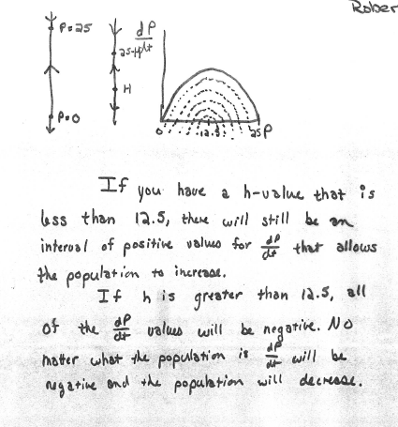

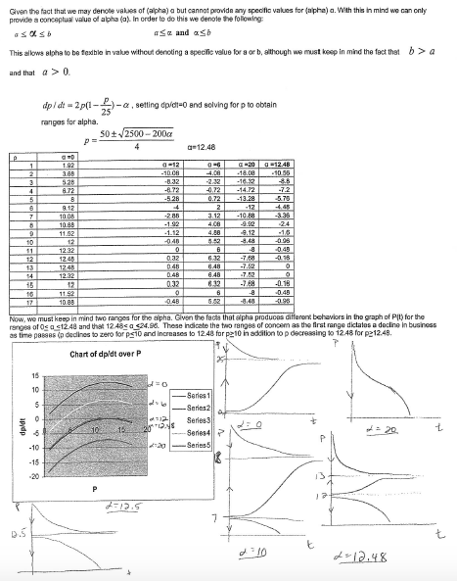

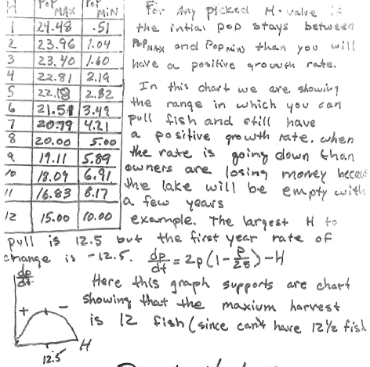

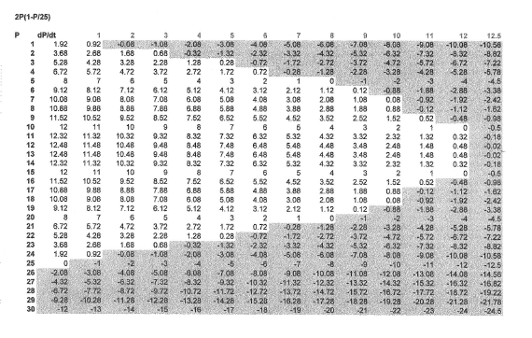

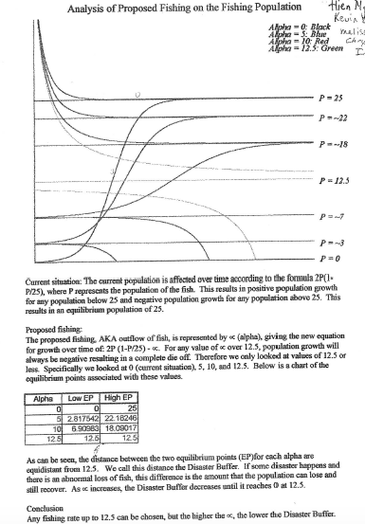

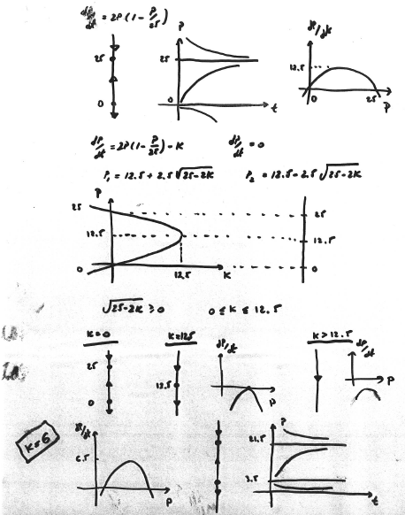

**Pages 8.4 - 8.6 - Climate Change**

*Question 4* takes about two 50-minute class meetings, and brings to close our discussion of first order, nonlinear dynamics.  The major lesson here is one of “small changes with big effects,” which are not so readily undone.  Students will extract essential information from a description of climate science, use a phase line to build their own differential equations model, and analyze a sequence of parameter changes in the context of that model.  The students will observe a hysteresis effect, one where a small change to a parameter has dramatic implications and a subsequent “undoing” of that small change fails to return the system to the previous state.  In this case, a small change in government deregulation causes a 6 degree global temperature difference, and undoing that small change fails to bring the global temperature back to acceptable levels.

Students do not struggle much with question a.  Question b will go a little more smoothly if you previously assigned homework 3 from unit 6, but this is of course not necessary.

*Question c* will mostly likely introduce a model very similar to ones that students’ came up with for themselves.  The 1/10 scaling factor in front of the model is simply to facilitate the choices of k that are used later in the sequence.

*Question d* invites the students to sketch the bifurcation diagram.  It should look like the bifurcation diagram below.  Students may have picked up on the fact that they can “just reflect the autonomous derivative graph through the line y=x” to obtain the bifurcation diagram.  You may want to point out that such a technique only works in situations where dx/dt = f(x) - k, because the critical points, for a given value of k, are when f(x) = k, essentially solving the inverse problem x = f^-1(k) where f is invertible.  If f is not invertible, the “flipped” graph is still appropriate, but of course is not a function.  Bifurcation parameters appear in many differential equations in many ways other than “-k.”

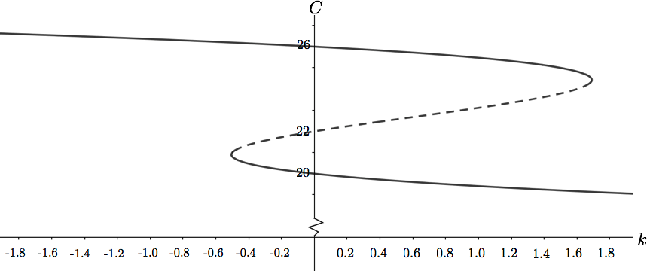

It is not essential that students draw an exact bifurcation diagram.  Finding the bifurcation points is a Calculus 1 exercise worthy of callout, but perhaps not worthy of spending a lot of class time on.  It is relatively simple to plot the autonomous derivative graph and use the y coordinates of the local extrema as  k-coordinates of the bifurcation values.  This can be done even by typing “y=1/10(x-20)(22-x)(x-26)” into google search and using the built in graphing calculator that shows above the search results.

*Question e* surprises students because this is their first encounter with hysteresis - the temperature will not be the same as the starting temperature!  One thing that is left out of the discussion is how long it is between changes of k.  Indeed, depending on the timescale of the differential equation, no change may happen at all!  If a student points this out, they should be congratulated.  Then an assumption should be added that the system is allowed to equilibrate between changes.

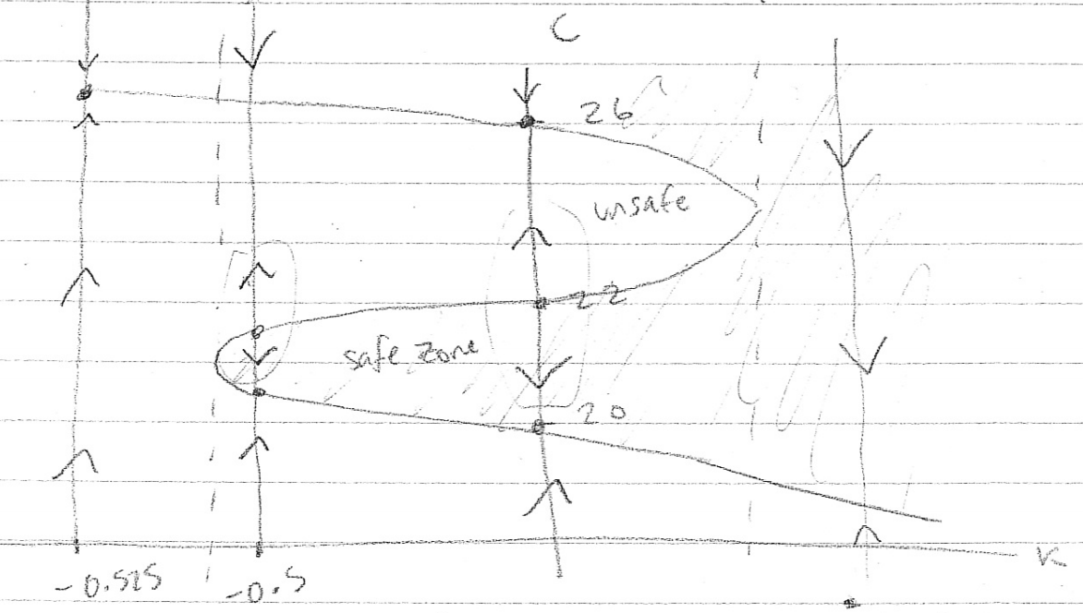

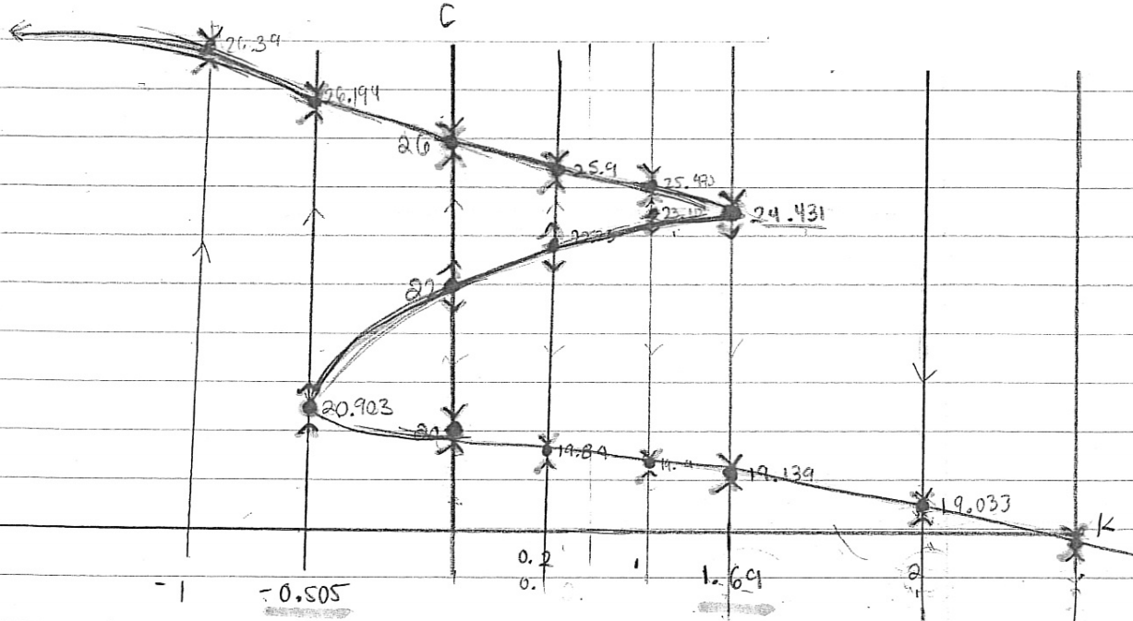

**Notes for Personal Reflections on Unit 8**